
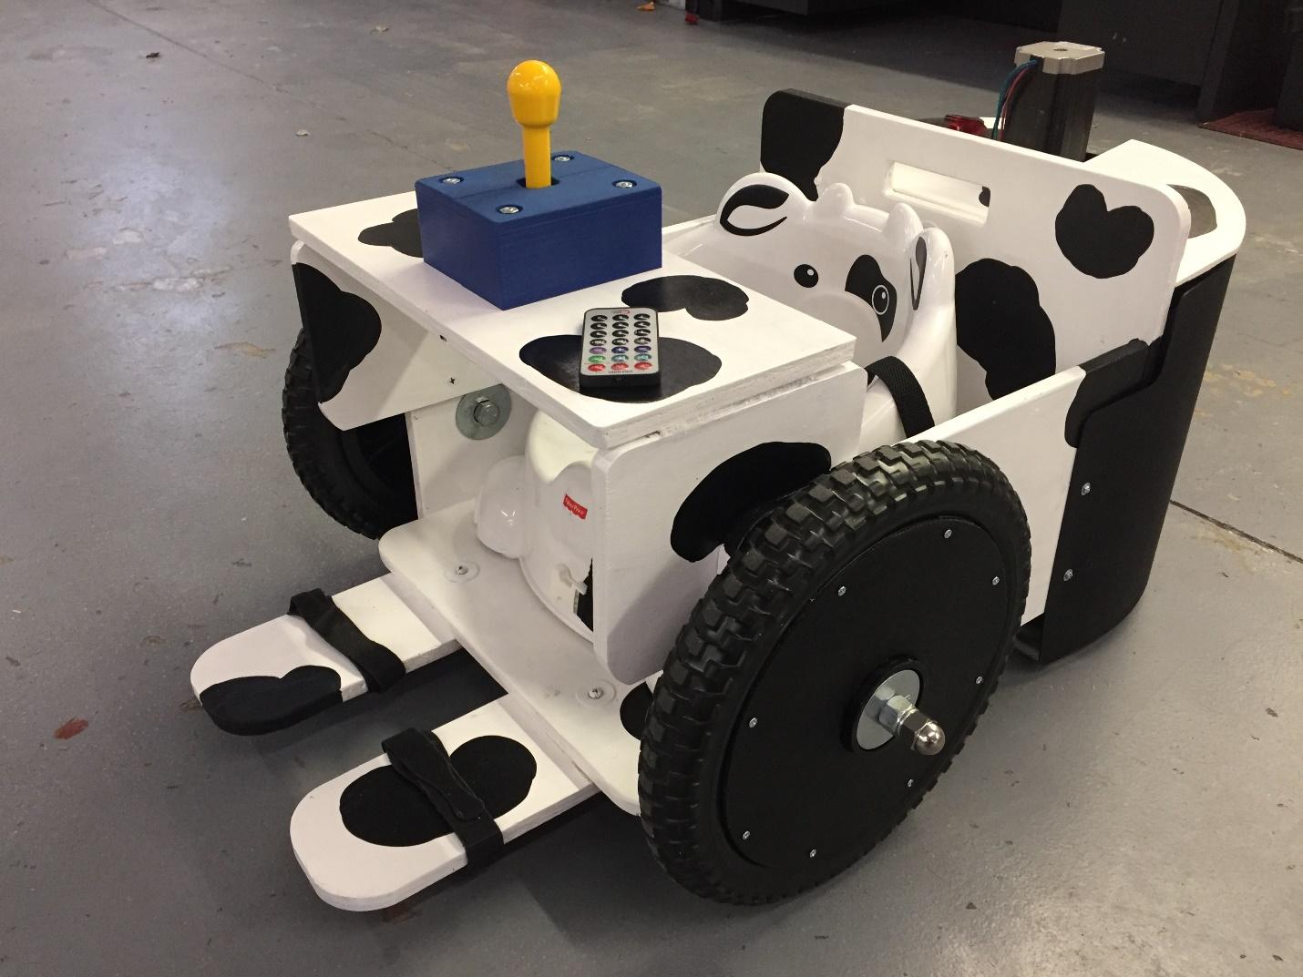
Sit N’ Moo(ve)
Guideline

- Device operation
- Please check if the steering motor is in range (not all the way to the right). The motor may move out of the right limit switch if the device is picked up sideway
- To turn on the device, open the red cover on the switch and push it to the on position (all the way because the switch has three positions)
- To go forward, push joystick forward
  - To turn left while going forward, push the joystick to the left while pushing the joystick forward
  - To turn right while going forward, push the joystick to the right while pushing the joystick forward
- To go backward, push joystick backward
  - To turn left while going backward, push the joystick to the left while pushing the joystick backward
  - To turn right while going backward, push the joystick to the right while pushing the joystick backward
- Push joystick to the left or right only will have no effect
- To turn off the device, close the switch cover
- The battery will last about an hour with continuous use. The obvious sign of low battery will be that the device will have no power moving backward

- Charging
- Open the top cover, unplug the red and black wires connected to the battery terminals, attach the red and black charging cable to the red and black terminal on the battery, respectively
- Plug in the charger with 12V option (not 6V)
- Please be careful not to move any other wires

- Emergency shutoff switch
- To turn off the device for emergency, close the switch cover

- Remote shutoff
- To remotely shutoff the device that is operating, aim the remote directly to the back of the device and press one of the red buttons on the first row. You may have to adjust your position properly to get it right. The red LED will turn on indicating that the device is temporarily disable
- To get back normal operation, aim the remote directly to the back of the device and press one of the green buttons on the second row

- Troubleshooting
- If the device is not working properly such as making weird jerking sound when trying to turn or need a repair. This could be due to wiring problem, please do not attempt to fix it yourself
- Please contact Dr. Henshaw at The University of Tulsa for repair

- Contact
John Henshaw – 918 631 3002
John-henshaw@utulsa.edu

